Remedy

System Design

Draft |  | Remedy |  | November 10, 2026

Authors | Project team
Reviewers | To be determined
Related docs | HACKATHON_STRATEGY.md
Scope | Sandbox merchant resolution prototype

1. Abstract
Remedy helps a merchant review a customer message, inspect the supporting evidence and approve a PayPal sandbox refund. Gemini proposes a review; PayPal remains the source of truth for payment state.
The current demo supports one sample case and a fixed USD 24 refund against a USD 72 sandbox purchase. It is not a production payments system.

2. Goals and Non-Goals
Goals | Non-goals
Review a sample case | Production payments
Complete sandbox refund | Automatic dispute adjudication
Explain financial status | Multiple merchants or tenants
Prevent duplicate local refunds | Guaranteed provider availability

3. Background and Problem Statement
Small merchants must reconcile a customer’s words with order details before resolving a problem. The prototype demonstrates that workflow with synthetic inputs and test funds.
The browser submits requests to a Next.js server. The server calls Gemini and PayPal, and stores transaction state in SQLite locally or PostgreSQL when configured.

4. Proposed Architecture

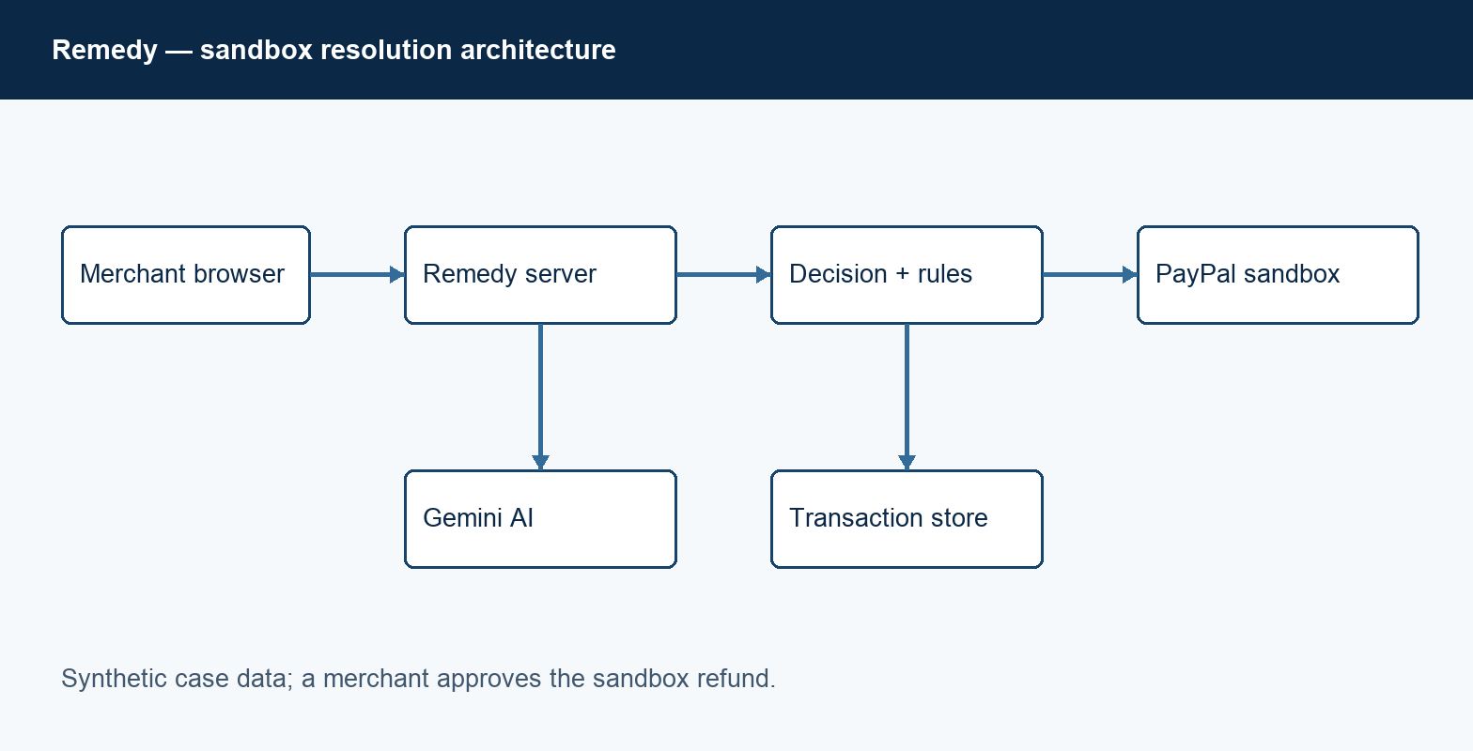
Figure 1. Sandbox resolution architecture.

Core components

Component | Responsibility | Storage | Failure behavior
Browser | Collect and show case | Client state | Show errors
AI route | Extract evidence | Gemini | Require review
Payment routes | Sandbox transactions | PayPal | Record outcome
Data store | Persist order and refund | SQLite / PostgreSQL | Fail closed
Access gate | Protect hosted demo | Environment | Deny unconfigured

5. Request Lifecycle
- The merchant reviews a sample message and creates a sandbox order.
- The server checks origin, bounds JSON input and limits action rates. Hosted access uses a shared demo password.
- The server loads sandbox credentials and the recorded order and refund state.
- Gemini extracts an issue and quoted evidence. The server validates the quoted substring.
- The order is recorded before checkout; a unique refund reservation is stored before the refund call.
- PayPal processes capture and refund requests. Uncertain outcomes remain unknown and require reconciliation.
- The interface displays returned status and identifiers. Sensitive credentials are not returned to the browser.

6. API and Data Contracts

Primary data contract

Field | Type | Required | Description
order_id | string | Yes | Sandbox order identifier
capture_id | string | After capture | Payment identifier
refund_id | string | After response | PayPal refund identifier
request_id | string | Yes | Idempotency identifier
amount | integer | Yes | Refund minor units
status | string | Yes | Observed action state
message | string | For review | Synthetic customer text

Contract guarantees

- A refund reservation is written before the PayPal side effect.
- The capture ID identifies one refund reservation; the request ID supports PayPal idempotency.
- The sample amount is fixed in the server. Versioned approval and policy records are future work.
- Local records track demo activity; PayPal is authoritative for payment and refund status.
API routes: POST /api/analyze, /api/order, /api/capture and /api/refund; GET /api/state.
Requests and transaction state are scoped to one shared demonstration workspace.

7. Consistency, Idempotency, and Replay

A unique reservation per capture prevents duplicate local refund submissions. A network timeout is not proof of failure; unknown outcomes must be checked before retrying.
Scenario | Expected behavior | Reason
Duplicate action | Return existing record | Unique capture reservation
Database unavailable | Reject action | Avoid untracked refund
Network timeout | Mark unknown | Reconcile before retry
Policy preview change | Preview only | No money moved

8. Security and Privacy Considerations

- Hosted access uses shared credentials and a workspace-wide failed-login limit. This is not multi-tenant merchant authentication.
- Use synthetic messages and avoid recording secrets or full provider responses in logs.
- Keep PayPal and model credentials server-side in deployment environment variables.
- PayPal is sandbox-only. A hosted service requires HTTPS APP_ORIGIN, DATABASE_URL, DEMO_PASSWORD and server-side provider keys.
- Preserve demo data through judging, then review removal and retention requirements.

9. Operational Readiness
Signal | Target or check | Owner | Gate
AI review | Returns supported evidence | Project owner | Required
Sandbox capture | Buyer can complete checkout | Project owner | Required
Refund | Status matches PayPal | Project owner | Required
Authentication | Unauthorized requests rejected | Project owner | Required
Persistence | State survives restart | Project owner | Required

10. Alternatives Considered

Alternative | Benefit | Tradeoff
SQLite | Simple local setup | Not durable on ephemeral hosting
PostgreSQL | Durable shared state | Requires hosted configuration
Automatic refunds | Fewer manual steps | Not selected for demo
Separate agent platform | Additional tooling | More integration work

11. Open Questions
- Confirm the sandbox buyer can complete checkout without a real payment method.
- Confirm AG Studio evaluation terms allow the intended hosted judging demo.
- Verify Render service and database pricing, credit coverage, persistence and availability through judging.
- Choose and securely distribute judge access credentials.

12. Decision and Next Steps
Complete sandbox purchase and refund testing; validate Render database persistence, authentication and service cost before opening judge access.
Milestone | Deliverable | Exit criteria
M1 | Sandbox purchase | Capture verified
M2 | Refund workflow | Refund and retry tested
M3 | Hosted demo | Auth and persistence tested
M4 | Submission | Judges can access demo

Use footnotes for definitions, assumptions, or terms that need precision without interrupting the main narrative.

